20/06/2022 – 24/06/2022

Achievements
Congratulations to all pupils and past pupils on their fantastic results in the Wales YFC Sports Day in Brecon on the 19th June.
Llwyddiannau
Llongyfarchiadau mawr i’r holl ddisgyblion a a chyn-ddisgyblion ar eu hymdrechion yn Niwrnod Chwaraeon CFfI Cymru Wales YFC ar y 19eg o Fehefin.

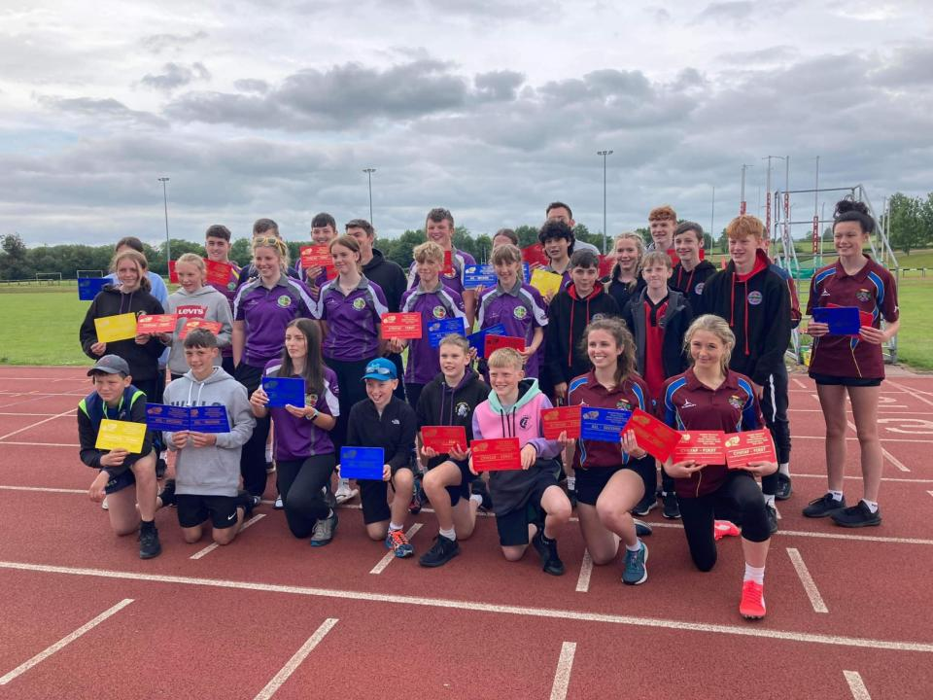

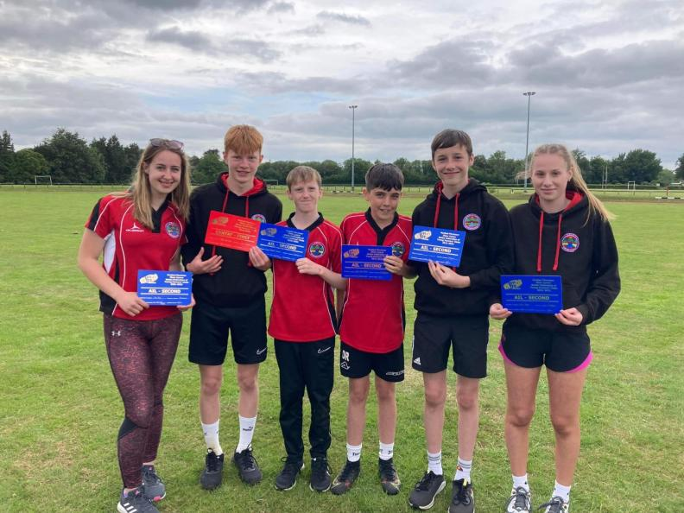

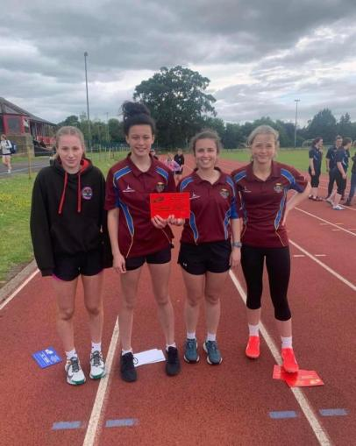

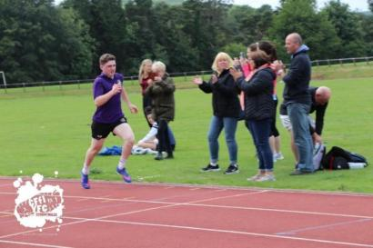

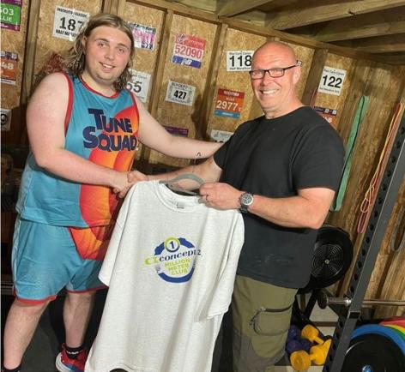
Rhwyfo
Mae Henry wedi cwblhau miliwn o fetrau ar ei beiriant rhwyfo cartref. Cwblhaodd her 'concept2' ddydd Sul. Da iawn Henry!
Rowing
Henry has achieved one million metres rowed on his home rowing machine, he completed the ‘concept2’ challenge on Sunday. Well done Henry!

BEICIO
Da iawn i Lowri Richards bl.12 am ennill Pencampwriaeth Cymru am ferched iau yn Aberystwyth ar y 4ydd o Fehefin. Da iawn hefyd i Lucy bl.12 am ddod yn 3ydd.
CYCLING
Very well done to Lowri Richards yr.12 for winning the Welsh Crit Champs (junior girls) in Aberystwyth on the 4th of June. Well done also to Lucy yr.12 for coming 3rd.

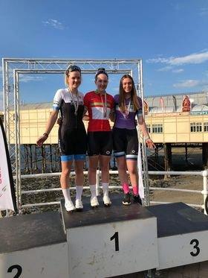
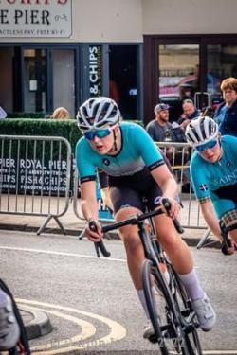

CANOLFAN CROESO
Our Canolfan Croeso pupils took part in a Rugby Festival last week. Well done all!
CANOLFAN CROESO
Cymerodd ein disgyblion ran mewn Gwyl Rygbi wythnos diwethaf. Da iawn Canolfan Croeso!

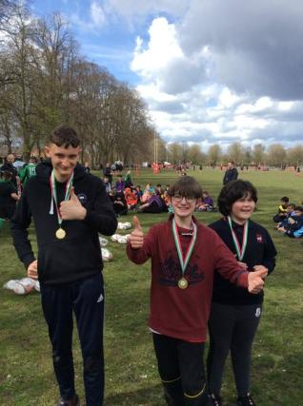
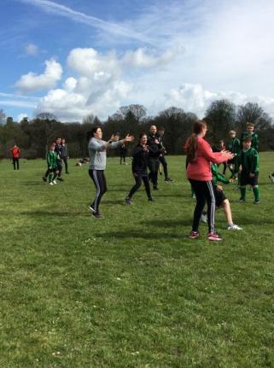

STONDIN GACENNAU
Roedd y stondin gacennau ar Mehefin 17eg yn ffantastig! Diolch yn fawr iawn i’r holl ddisgyblion Gwobr Dug Caeredin blwyddyn 12.
BAKE SALE
It was a fantastic bake sale on the 17th June! Thank you so much to all of the Duke of Edinburgh pupils in year 12.

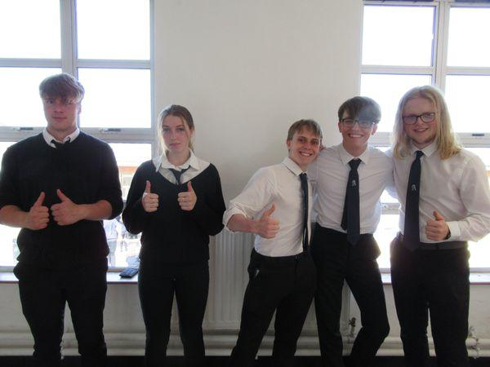
CANOLFAN CROESO
Aeth Canolfan Croeso i Llain a mwynhau gan gymryd rhan mewn dringo rhaffau uchel a saethyddiaeth.
Gwaith tîm gwych a gwelwyd pob disgybl yn cwblhau'r heriau! Ardderchog!

CANOLFAN CROESO
Canolfan Croeso students went to Llain Activity Centre and enjoyed taking part in climbing high ropes and archery.
Fantastic teamwork and every student smashed the challenges! Great job!

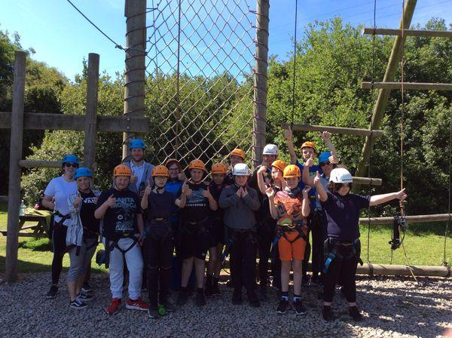

Os oes gan unrhyw riant/gwarcheidwad gyflawniad yr hoffent ei gynnwys, anfonwch neges atom ar Facebook gyda llun os gwelwch yn dda. Diolch.
If any parent/guardian has an achievement they would like included please message us on Facebook with a photo. Thank you.

Nodyn y Pennaeth
- Da iawn i bawb ym mlwyddyn 7 ac 8 sydd wedi bod yn sefyll arholiadau'r wythnos yma. Dangosodd y disgyblion agwedd ardderchog yn ystod eu cyfnod cyntaf o gwblhau arholiadau ffurfiol.
- Mae nifer o ddisgyblion Bl 7, 8 a 9 wedi bod yn cwblhau profion rhifedd a llythrennedd yn ystod yr wythnos. Bydd rhai disgyblion yn cwblhau’r profion yn ystod y bythefnos nesaf. Does dim posib i ddisgyblion adolygu ar gyfer y profion yma, dim ond trial eu gorau. Bydd y profion yn gymorth i’r ysgol a disgyblion trwy ddangos beth gall ddisgyblion wneud a beth sydd angen parhau i ddatblygu.
- Mae Prom Bl 11 i’w gynnal yn yr ysgol Dydd Iau, Mehefin 30^{ain}. Gobeithio bydd yr haul yn gwenu.
- Does dim ysgol i ddisgyblion ar Ddydd Gwener, Gorffennaf ^{1af} gan fod hi’n ddiwrnod hyfforddiant mewn swydd.

Headteacher’s Note

• Well done to everyone in years 7 and 8 who have been sitting exams this week. Pupils have demonstrated an excellent attitude during their first period of completing formal examinations.
• Many Year 7, 8 and 9 pupils have been completing numeracy and literacy tests during the week. Some pupils will complete the remainder of these tests in the next two weeks. It is not possible for pupils to revise for these tests, just try their best. The tests will help the school and pupils by showing what pupils can do and what needs to continue to be developed.
• The Yr 11 Prom is to be held at the school on Thursday, June 30th. Hopefully the sun will shine.
• There is no school for pupils on Friday, July 1st as it is an in-service training day.

