04/07/2022 – 08/07/2022

Achievements
Some of our pupils took part in the Only Boys Aloud, Only Kids Aloud and Merched Aloud Girls concert in Cardiff on Sunday. A mini bus of staff and pupils went to support the four - it was excellent to see them singing so passionately in their respective choirs. Ela and Fflur were also selected for solo parts. Congratulations to them all! 🎼
If you would like to buy their album, Gen Z, here’s the link!
https://aloudcharityshop.bigcartel.com/product/gen-z
Llwyddiannau
Dyma lun o ddisgyblion Ysgol Gyfun Aberaeron a wnaeth gymryd rhan yng nghyngerdd The Aloud Charity (Only Boys Aloud, Only Kids Aloud a Merched Aloud Girls) nos Sul. Canodd y pedwar gydag angerdd yn eu corau a chafodd Fflur ac Ela eu dewis i ganu darnau unigol hefyd. Llongyfarchiadau mawr i chi gyd - gwnaeth y criw bach a deithiodd o’r Ysgol i’ch cefnogi fwynhau’r profiad yn arw. Gwych! 🎼
Os hoffech chi brynu eu halbwm, Gen Z, dyma’r ddolen!
https://aloudcharityshop.bigcartel.com/product/gen-z

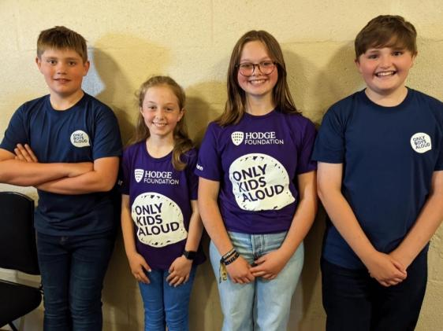

Pencampwriaethau Athletau Ysgolion Cymru.🎽 Llongyfarchiadau mawr i Cordelia Walker a Rhys Williams ar eu llwyddiant ddoe ym Mhencampwriaethau Athletau Ysgolion Cymru. 🏴
1af - Cordelia Walker, Gwaywffon/ Javelin
3ydd - Rhys Williams, Naid Driphlyg/ Triple Jump
National Schools Athletics Championships. 🎽 Congratulations to Cordelia Walker and Rhys Williams on their excellent results yesterday at the National Schools Athletics Championships. 🏴
Gold - Cordelia Walker, Gwaywffon/ Javelin
Bronze - Rhys Williams, Naid Driphlyg/ Triple Jump
Duke of Edinburgh expedition Alldaith Dug Caeredin
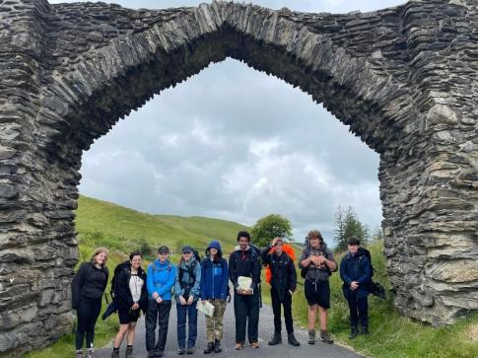
🎊 Dyma waith celf gan rhai o ddisgyblion Bl. 7, 8 a 9 yr Ysgol er mwyn harddu’r ardal a chroesawu pawb i Eisteddfod Genedlaethol Ceredigion 2022 yn Nhregaron.
🎊 Here ia a photo of recent art work completed by pupils in Year 7, 8 and 9 in order to decorate the local area and welcome everyone to Ceredigion National Eisteddfod 2022 in Tregaron.
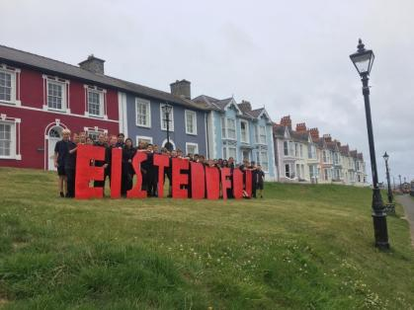

Dr Stuart Jones
Yesterday we had Dr Stuart Jones giving a lecture to our 6th form students about motivation, resilience and stress management. A really interesting talk – thank you very much UWTSD.
Dr Stuart Jones
Ddoe, buodd Dr Stuart Jones o Brifysgol Cymru y Drindod Dewi Sant yma yn gwneud gweithdy ar sut i reoli straen a gorbryder gyda’r chweched dosbarth. Gwybodaeth ddiddorol iawn – diolch yn fawr PCDDS.

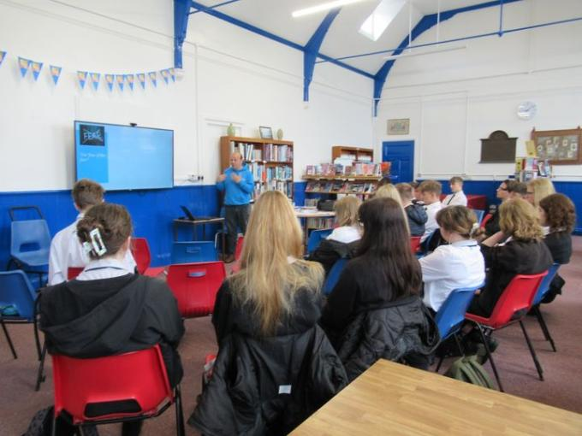
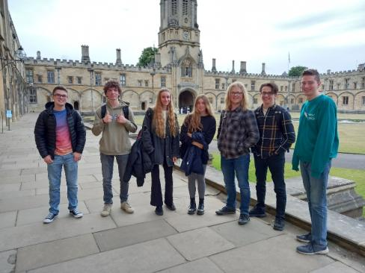
Diwrnod agored Oxford Bl.12 Yr.12 Oxford open day

Os oes gan unrhyw riant/gwarcheidwad gyflawniad yr hoffent ei gynnwys, anfonwch neges atom ar Facebook gyda llun os gwelwch yn dda. Diolch.
If any parent/guardian has an achievement they would like included please message us on Facebook with a photo. Thank you.
Nodyn y Pennaeth
- Hyfryd oedd gweld pawb yn cystadlu yn ystod Mabolgampau’r ysgol ar Ddydd Gwener yr 8fed. Cefnogi ei gilydd a mwynhau’r diwrnod oedd bwriad disgyblion a hynny a gafwyd – da iawn bawb.
- Wythnos nesaf fydd wythnos olaf y flwyddyn academaidd. Hoffwn ddiolch i bob disgybl am eu gwaith hyd yn hyn a gofyn am yr un safonau uchel o ymddygiad ac ymdrech wythnos nesaf.
- Ar fore Llun, bydd prawf sillafu i ddisgyblion Blwyddyn 7 a phrawf sillafu i ddisgyblion Blwyddyn 8 ar Ddydd Mawrth. Bydd hyn yn gymorth i ni wrth drefnu unrhyw ymyraethau ar gyfer cefnogi disgyblion blwyddyn nesaf.
- Mi fydd gwersi arferol yn parhau wythnos nesaf ynghyd a rhai gweithgareddau diwedd tymor fel y daith i Oakwood ar Ddydd Iau.
- Dydd Gwener fydd diwrnod olaf y flwyddyn.
- Bydd yr ysgol yn rhyddhau canlyniadau lefel A ac AS ar Ddydd Iau, Awst 18 o 8.30yb a chanlyniadau TGAU ar Ddydd Iau, Awst 25ain.

Headteacher’s Note

• It was wonderful to see everyone competing during the school Sports on Friday the 8th. The pupils' intention was to support each other and enjoy the day and that was achieved - well done everyone.
• Next week will be the last week of the academic year. I would like to thank all pupils for their work so far and ask for the same high standards of behaviour and effort next week.
• On Monday morning, there will be a spelling test for Year 7 pupils and a spelling test for Year 8 pupils on Tuesday. This will help us when organising any interventions to support pupils next year.
• Normal lessons will continue next week along with some end of term activities such as a trip to Oakwood for many pupils on Thursday.
• Friday will be the last day of the academic year.
* A level results should be collected from the school from 8.30am on Thursday, August 18th and GCSE results should be collected from 8.30 on Thursday, August 25th.

