11/07/2022 – 15/07/2022

Achievements
2022-2023 NEW SENIOR PREFECTS YSGOL GYFUN ABERAERON
Congratulations to the Ysgol Gyfun Aberaeron Senior Prefects who have been elected to lead during the academic year, 2022-2023. These pupils were elected firstly by letter of application, a vote and then received an interview before being appointed.
Left to right: Rhys Roberts, Osian Jones, Ethan Walsh, Lowri Richards, Jake Willis, Sion Evans.
Llwyddiannau
PRIF SWYDDOGION NEWYDD YSGOL GYFUN ABERAERON 2022-2023
Llongyfarchiadau i Brif Swyddogion Ysgol Gyfun Aberaeron am y flwyddyn 2022-2023. Cawson nhw eu hethol i arwain yn ystod y flwyddyn academaidd 2022-2023, yn gyntaf drwy lythyr cais, pleidlais ac yna cyfweliad, cyn cael eu hapwyntio.
O’r chwith i’r dde: Rhys Roberts, Osian Jones, Ethan Walsh, Lowri Richards, Jake Willis, Sion Evans.

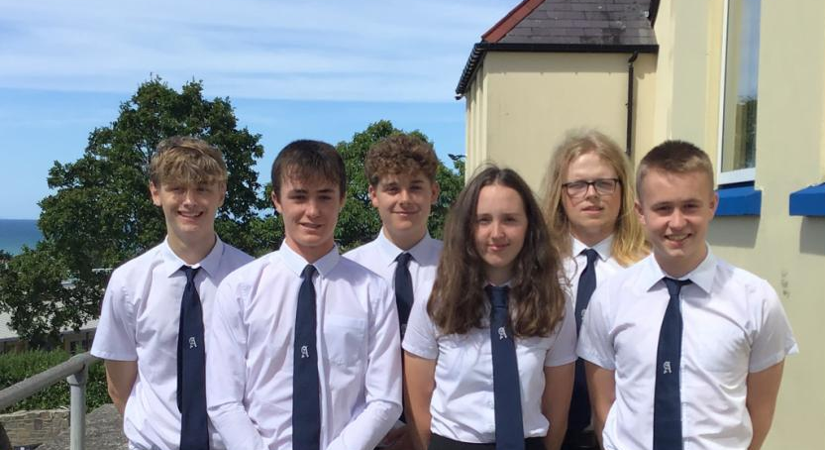
Da iawn Cordelia! 👏🏼🎽 Well done Cordelia!
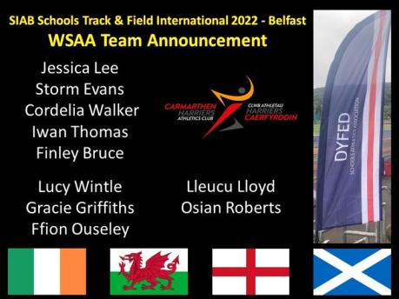
MABOLGAMPAU 2022
Llongyfarchiadau mawr i bawb fu’n cystadlu ym mabolgampau’r Ysgol ddydd Gwener. Cafwyd diwrnod gwych o gystadlu; gwelwyd cannoedd o blant yn rhoi o’u gorau mewn ystod eang o weithgareddau a thorrwyd sawl record hefyd. Diolch i’r holl staff am eu cefnogaeth.
🥇Tyglyn 1af
🥈Tanyfron 2ail
🥉Portland 3ydd
Lluniau ar Facebook YGA
SPORTS DAY 2022
Congratulations to all pupils who competed in our school sports day on Friday. Hundreds of children were seen giving their all in a range of events and some records were also broken. Thank you to all staff members for their support in ensuring the smooth running of all competitions.
🥇Tyglyn 1st
🥈Tanyfron 2nd
🥉Portland 3rd
Photos on Facebook YGA
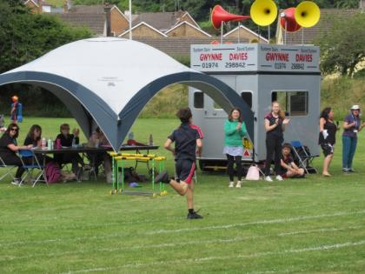
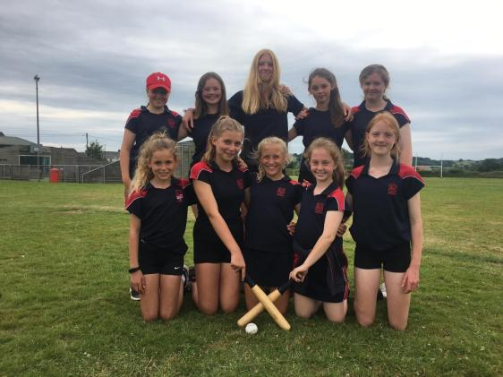
⚾️ Congratulations to our Year 7 girls on coming 3rd in the Ceredigion Rounders Tournament 🥉
⚾️ Llongyfarchiadau i ferched Bl. 7 ar ddod yn 3ydd yn Nhwrnament Rownderi Ceredigion 🥉

Duke of Edinburgh expedition Alldaith Dug Caeredin
Da iawn i’r disgyblion (a staff!) sydd wedi cwblhau yr alldaith ar gyfer Gwobr Aur Dug Caeredin! 130 cilomedr lawr yr afon Gwy - llwyddiant mawr!
Well done to all the pupils (and staff!) who have successfully completed their Gold Duke of Edinburgh award expedition! 130km down the river Wye - a great accomplishment! 🎉
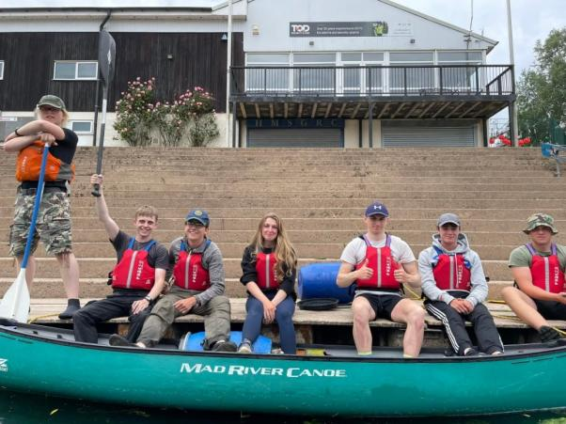

Os oes gan unrhyw riant/gwarcheidwad gyflawniad yr hoffent ei gynnwys, anfonwch neges atom ar Facebook gyda llun os gwelwch yn dda. Diolch.
If any parent/guardian has an achievement they would like included please message us on Facebook with a photo. Thank you.

Nodyn y Pennaeth
- Dymuniadau gorau i holl ddisgyblion a staff yr ysgol at wyliau’r Haf a diolch i bawb am eu gwaith a’u caredigrwydd yn ystod y flwyddyn. Hoffwn ddiolch hefyd i rieni a gofalwyr ein disgyblion sy’n fodlon cydweithio gyda’r ysgol er mwyn cefnogi pobl ifanc Aberaeron a’r ardal.
- Hoffwn longyfarch yn arbennig ein prif swyddogion newydd ar gael eu penodi i’r rôl. Rydym yn ffodus iawn o safon uchel pob un o’r 14 o ymgeiswyr am y cyfle yma.
- Nodyn atgoffa bydd yr ysgol yn agor am 8.30 ar Ddydd Iau, Awst 18fed ar gyfer canlyniadau Lefel A ac am 8.30 ar Ddydd Iau, Awst 25ain ar gyfer canlyniadau TGAU.
- Bydd yr ysgol yn ail-agor i staff ar Fedi’r 1af ac i ddisgyblion ar Ddydd Llun, Medi’r 5ed.

Headteacher’s Note

• Best wishes to all the school's pupils and staff for the Summer holidays and thanks to everyone for their work and kindness during the year. I would also like to thank the parents and carers of our pupils who are willing to collaborate with the school in order to support the young people of Aberaeron and the area.
• I would especially like to congratulate our new senior prefects on being appointed to the role. We are very fortunate of the high standard of all 14 candidates for this opportunity.
• A reminder that the school will open at 8.30 on Thursday, August 18th for A Level results and at 8.30 on Thursday, August 25th for GCSE results.
• The school will re-open for staff on September 1st and for pupils on Monday, September 5th.

